Jennifer Chapman
MWF 10:00 – 10:50

In the study conducted, we desired to see possible correlations between age and studying habits. Unfortunately, the data was incorrectly recorded in the beginning but was later corrected. For this first data set, I decided to focus on the correct data, as it was what we desired to know. The incorrect data is also provided on the following page.

(Correct Data)
Summary statistics:
Column | n | Mean | Variance | Std. Dev. | Std. Err. | Median | Min | Max | Q1 | Q3
AGE | 26 | 20.807692 | 7.4415383 | 2.7279184 | 0.5349888 | 20 | 18 | 26 | 19 | 22
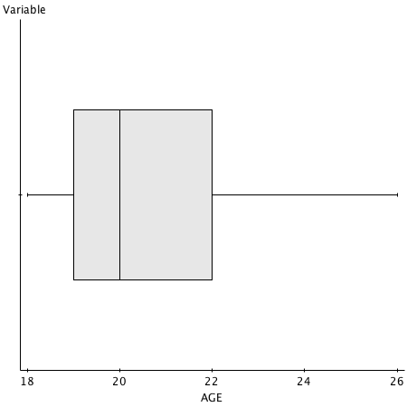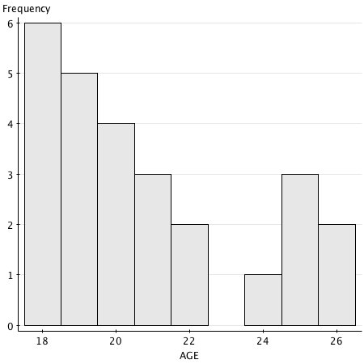

Summary statistics:
Column | n | Mean | Variance | Std. Dev. | Std. Err. | Median | Min | Max | Q1 | Q3
STUDYING | 26 | 3.9961538 | 2.6307845 | 1.6219693 | 0.31809437 | 4.05 | 1.1 | 8.1 | 2.8 | 5.2
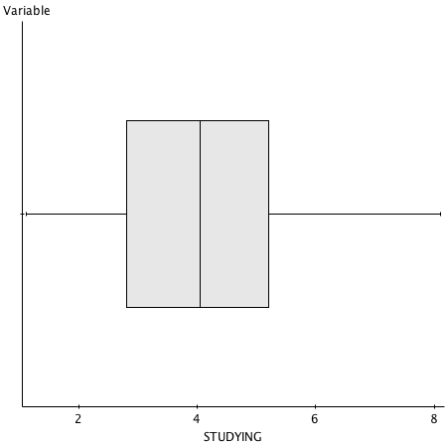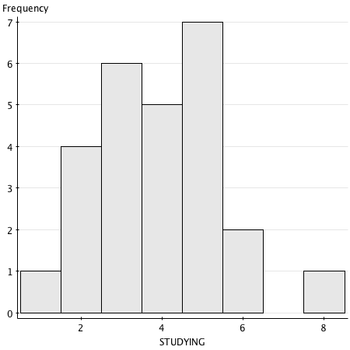
(Incorrect Data)
Summary statistics:
Column | n | Mean | Variance | Std. Dev. | Std. Err. | Median | Min | Max | Q1 | Q3
AGE | 26 | 21.192308 | 14.641539 | 3.8264263 | 0.75042397 | 20 | 18 | 35 | 19 | 22

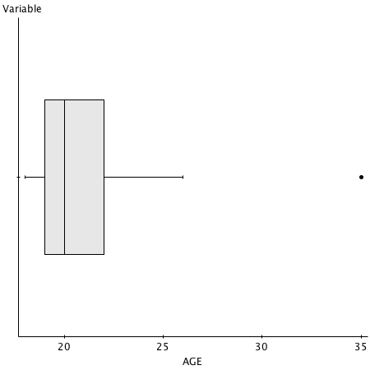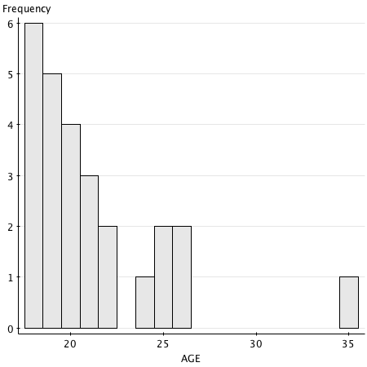

Summary statistics:

Column | n | Mean | Variance | Std. Dev. | Std. Err. | Median | Min | Max | Q1 | Q3
STUDYING | 26 | 3.9961538 | 2.6307845 | 1.6219693 | 0.31809437 | 4.05 | 1.1 | 8.1 | 2.8 | 5.2

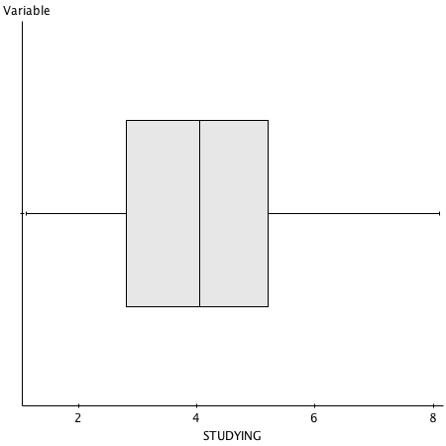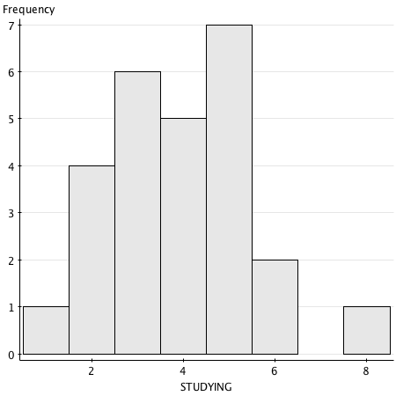

Scatter Plot (Correct Data)
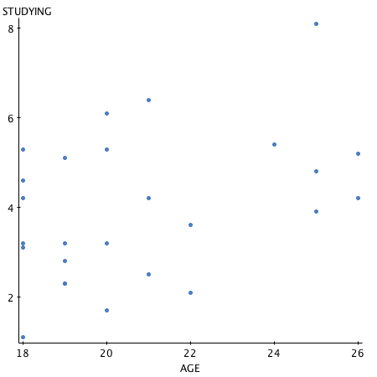

Scatter Plot (Incorrect Data)
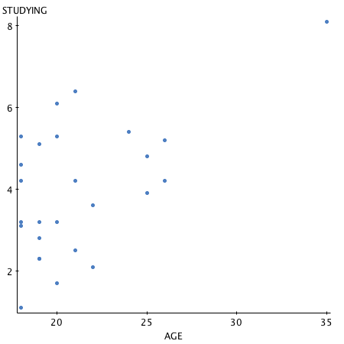

Data:
Dependent Variable: Hours Studying
Independent Variable: Age
y(hat) = .236x + -.912
Sample Size: 26
Correlation Coefficient (R) = .3967
Critical Value = (24 Degrees of Freedom) = .3882
Because the absolute value of .3976 is greater than .3883, we may conclude that there is significant linear relationship between age and hours studying per week. This being said, it is weak.

The Results:

- We are 99% confident that the mean age is between 19 and 23.

- There is sufficient evidence to conclude the mean age is less than 22.

- We are 95% confident that 56 – 91% of students studied more than three hours per week.

- If a 5% margin of error were desired, the sample size would need to be at least 303 people.

