Jen Chapman
Persuasive Essay

It’s acceptable to say that the role and expectations of American women has changed dramatically in recent years comparatively to American history. Society has become much more comfortable seeing women in a new light. The fact that women are able to work and provide for themselves as well as their families is becoming more common and a cultural norm. There are many successful single mothers. A woman gaining a full educational experience is a frequent occurrence. Powerful, profound women can be found everywhere, in government, business, on television, and in sports. But when does being a quality mother become a bad thing?
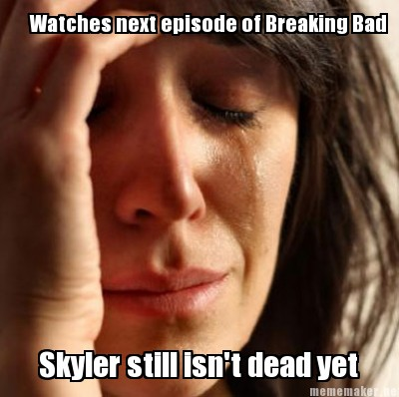
Anna Gunn portrays Skyler White in television’s “Breaking Bad.” Skyler is a mother of a 16-year-old son, a newborn daughter, and wife to a high school chemistry teacher (the lead character) named Walter. When her husband is diagnosed with cancer and begins to make changes in life, including secretively becoming one of the biggest drug lords of the West, Skyler’s world starts crumbling beneath her feet. It’s common in the social media world of “Breaking Bad” to hear “I HATE Skyler,” “Skyler’s such a bitch,” or “She just needs to die already.” In fact, I have never met someone who thinks otherwise… except myself. It’s interesting to see the hatred directed at Skyler because she honestly is an amazing woman. She’s a loving mother, good spouse, and will do anything to keep her loved ones safe. In today’s society, having these qualities can be considered negative, supposedly showing signs of “weakness” or “following stereotypes.” I may be old fashioned, but when did those qualities become a bad thing? Now, I understand Skyler is far from perfect. She’s human. She makes wrong decisions as well as many characters in the show, but I feel as if her negative actions are typically the emotional response to her surroundings.

Throughout the five-season ride of “Breaking Bad” you see Skyler begin as the stay at home mom: cooking breakfast, taking care of the family, cleaning, etc. She had a job previously but gave it up to stay at home with the family. This being said, she seems to “wear the pants” in the marital relationship and can sometimes overlook her introverted partner.
One of the beautiful concepts about “Breaking Bad” is that the director has added many subliminal messages in each episode revealing how incredibly important Skyler is to Walter. When Walter is diagnosed with terminal cancer, (and keeps it a secret) he begins to change, becoming more bold and daring. Before anyone knows of the deadly disease eating away at his lungs, he starts a life as a meth cook to gain money to leave with the family after his death. As Skyler begins to notice the change in Walter, she becomes worried and starts to ask questions. After weeks of lies, he finally reveals that he is dying and does not want to get treatment. Skyler, who is crushed, does everything in her power to convince him otherwise, ignoring his original plans. He finally consents.
As the chemotherapy begins to set in, Walter is only getting deeper into the drug trade, wanting more power and more money but is incredibly cautious about anyone finding out. He continues to lead a life of lies, which never seems to end. After countless talks between the couple consisting of “Where were you?” and “I was busy.” Skyler rolls into a deep depression. Walt completely shuts her out. It isn’t until he wants to please himself, almost raping her, that he will make time for her.
Skylar decides that Walt is having an affair and turns the tables and shuts him out. She gets a job, spends more time with her sister, and does anything to not be around Walt. She ends up committing adultery, sleeping with her boss. Walt suddenly longs for their relationship when he realizes she is going out and being just as secretive as he is. Soon enough, Skyler finds out about Walt’s other life as the drug lord “Heisenberg.”
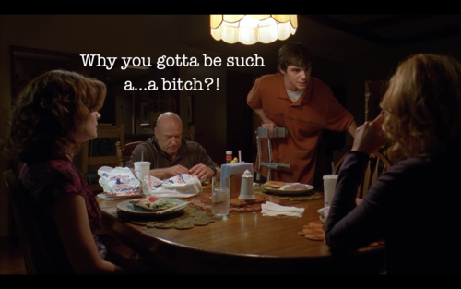
After dealing with the shock she is prepared to go the police but Walt begins to convince her that their family is benefiting from the income. Skyler immediately bans Walt from coming near her or the children, kicks him out of their home, and starts the procedure for divorce. The horrors of drug deals gone bad begin to become a reality and Skyler tries her best to make it on her own with Walter Jr. and their infant child, Holly. She is able to keep Walt at bay until rumors start spreading. As extended family becomes concerned, Walt begins to make up lies about their relationship leaving the fault with Skyler. This story arch finally ends with their son, Walt Jr., blaming the ruined marriage on Skyler.
Eventually Skyler, too, gets dragged into Walt’s deceivingly dangerous world of drugs, power, and money. She becomes stuck and is not only manipulated by Walt but is also used as leverage on occasion by Walt’s enemies. While she is trying to find her way out of this wormhole created in her life, she continues to do whatever it takes to protect her children and loved ones. Skyler is endlessly strong in the incredibly abusive relationship, but finally begins to break within the final season. She pleads with Walt to hang up his hat as the great “Heisenberg” for the children’s safety. This makes him angrier and for the first time the audience realizes Walt is no more, power-hungry Heisenberg has taken over. As she fights against the rage of the storm that is “Breaking Bad,” her eyes, which were at one point deeply loving, now only hold obscurity.
The story isn’t over until next summer, but it is rumored that there has been foreshadowing of Skyler’s death. Theories say that Walt will finally kill her.
It’s incredible to me that people do not root for Anna Gunn’s deep character until the final season, when the man who was once good has become an evil monster. Although many people still do not like her, they are more sympathetic which is what she deserves.
“Breaking Bad” creator and director, Vince Gillian, tries to explain why there is so much hate towards Sklyer’s character:
“You are definitely not even close to being the first person to say that. It’s just a funny thing about storytelling. Even when your hero is not a nice person and he’s doing bad things… you start to see the world through his eyes… You’ll root for that person to succeed. And right now, Skyler gets in the way, on a purely mechanical level, of Walt’s success and happiness and therefore we see her as an obstacle and we don’t like her for what she’s doing. So you’re not alone in feeling that way. But the funny thing is, I see Skyler as the good guy and Walt as the bad guy.”
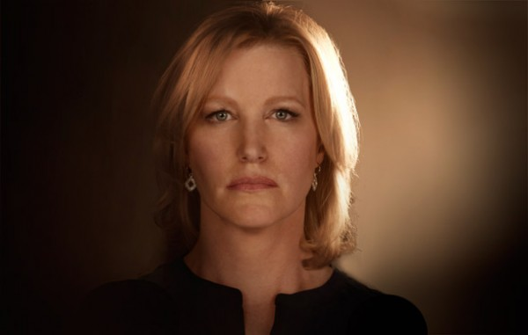
I will always support and fight for Skyler. She deserves a better reputation with the audience. Anna Gunn also deserves to be seen for the wonderful actor she is. So often people (including myself on occasion) forget that the character and the actor are not the same. It upsets me that she is detested so strongly but I hope and pray that the storyline will end with her redemption and victory no matter what the outcome.

n. page. Web. 26 Nov. 2012. <http://www.scriptphd.com/chemistry/2010/04/13/interview-breaking-bad-creatorexecutive-producer-vince-gilligan/>.

